**Project: A Variant of Sorry! (Board Game)**

This board game can be played by a minimum of two players and a maximum of four players. The most widely-accepted version of the game’s board is structured as follows:

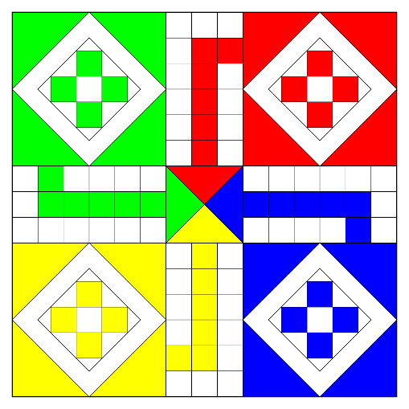

Each player is given four “tokens” that they can move around the board. The direction of movement for one player is explained in the following diagram:

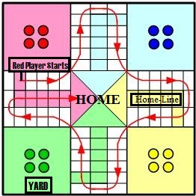

Every player has to move clockwise and the objective is to reach the center (or “home”) of the board first. The movement is controlled by the number obtained through rolling a dice.

**Rules:**

1. At the beginning, all four players take their turns to roll the dice. Whoever obtains number 6 gets to move their first token, first.
2. The number of steps moved correspond to the number given by the dice. If a player obtains a number 6, then the only he has is to take out his token. If he can’t do that, then his turn is simply passed.
3. If a player makes a wrong (foul) move, violating the rules of the game, he has to give up his turn.
4. If the tokens of two different players land on the same square, then the previous occupant of the square gets taken out, and has to start over again. However, if the square is present in the shaded region (i.e. a colored line), then multiple tokens can stay together in that square.
5. To reach the home, the player’s must either get either on the finishing box (box no. six in the home lane) or get past it. For example, if a player needs 3 to get to the finishing boxes and gets any number equal to 3 or more, his token gets into its home.
6. A player need to get all four of their tokens in the home in order to win the game. Once a player has won, he is no longer active in the game. The other players, however, continue the game.